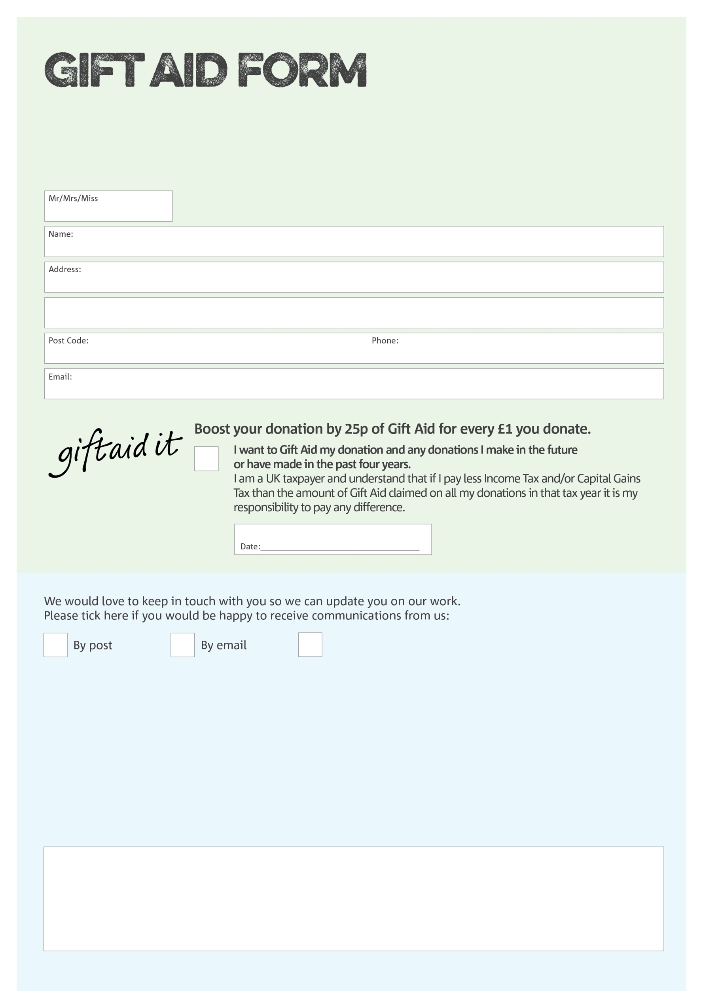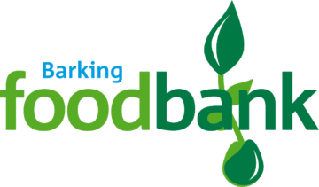

By filling in this form Barking Foodbank will receive an extra 25p for every £1 you give at no extra cost to you. Thank you!

You can change your preferences any time by contacting us on 02088610660 or emailing us at barkingfoodbank@gmail.com

I do not wish to receive future communications from Barking Foodbank

**Data protection**

*'Barking Foodbank is committed to protecting your privacy and will process your personal data in accordance with current Data Protection legislation. Barking Foodbank collects information to keep in touch with you and supply you with information relating to our work. To unsubscribe from our newsletter, send a message to the email address above with the word unsubscribe in the subject line. A full data privacy statement for financial donors is available from the foodbank on request.’*

We would love to know why you have chosen to donate to Barking Foodbank. If you would like to share your motivation let us know below:

Charity Number 1157921. Registered in England & Wales